LAB PROGRAMS

Question 26. Recursive printing with multiplication

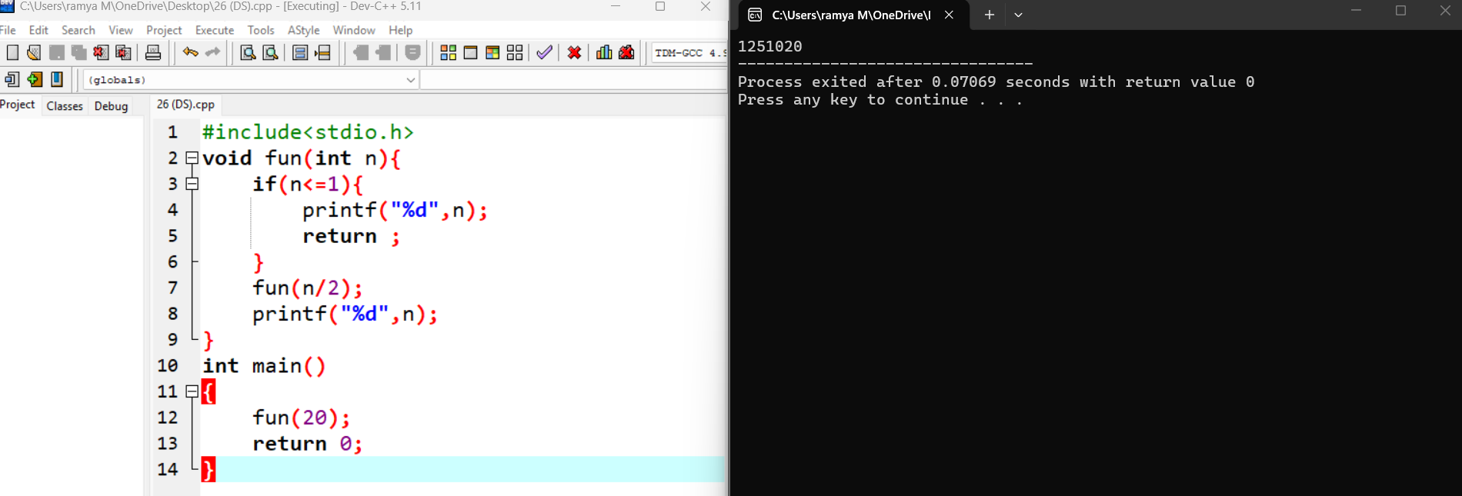

Question 27. Recursion and multiple recursive calls

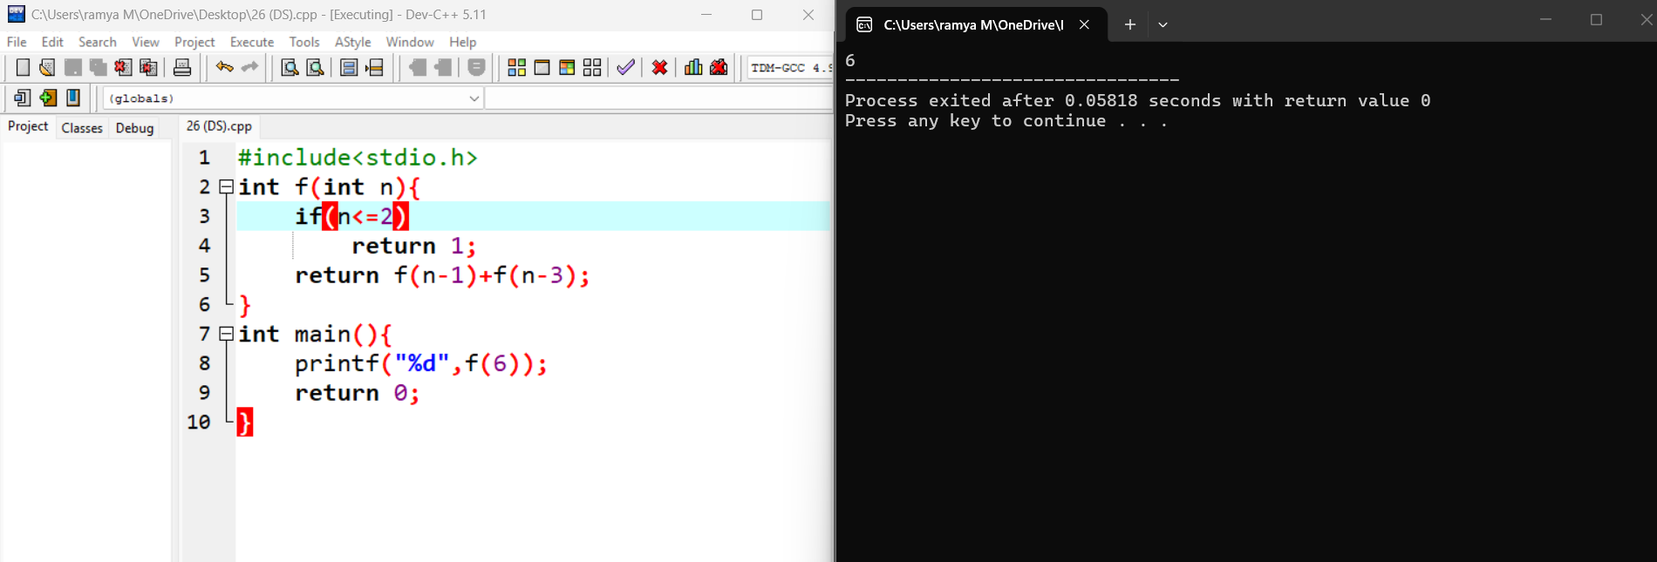

Question 28. Recursive function with a static variable

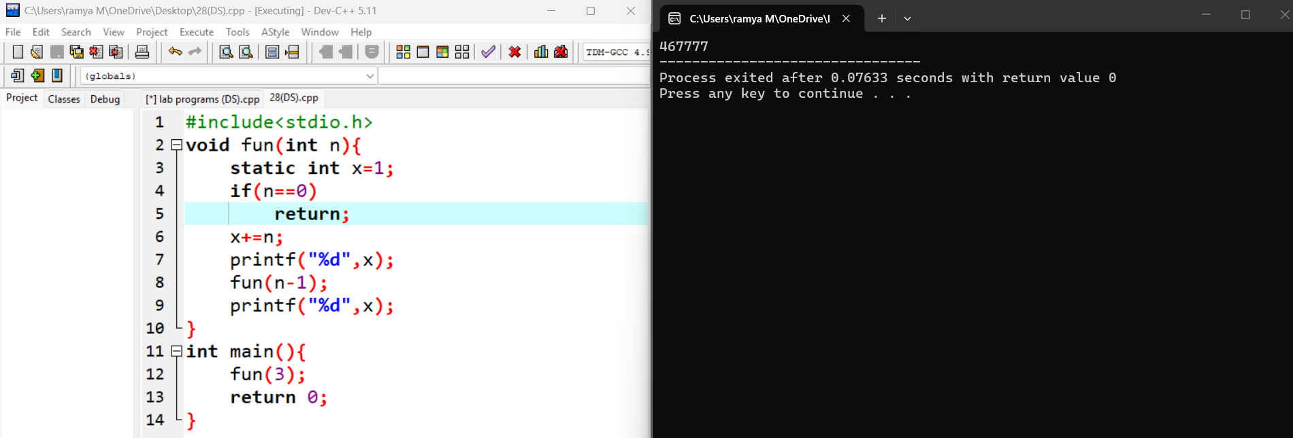
--Reason: A static variable is shared across all recursive calls and is not restored to its previous value when a call returns.

Question 29. Recursive array processing

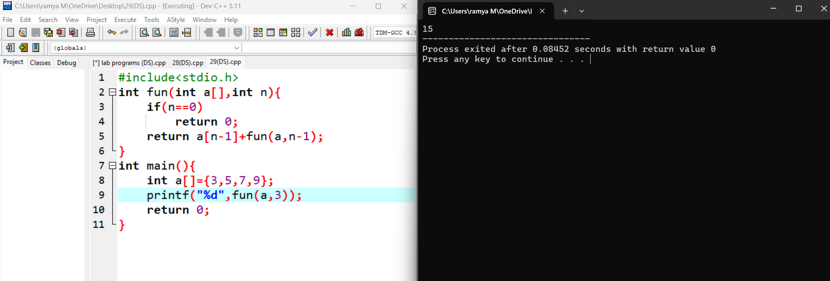

---The function adds the first three array elements:
The element 9 is not included because the function is called with n = 3.

Question 30. Recursion with a global variable

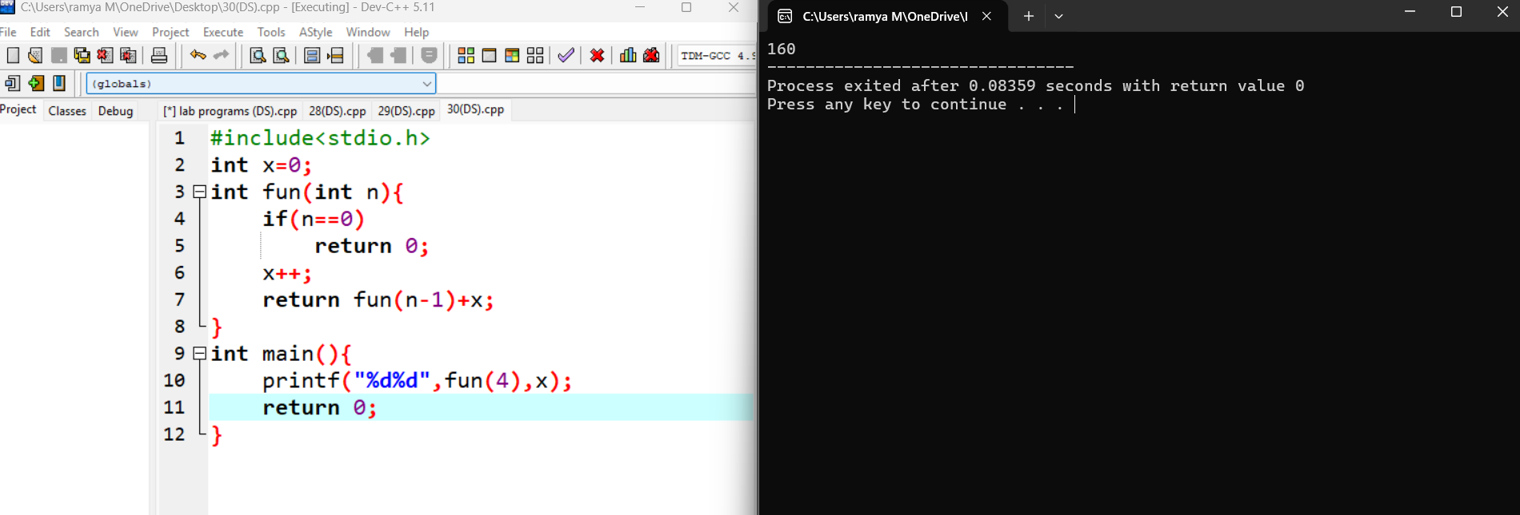

---the output is unspecified, either 16 4 or 16 0; the first value is always 16, but the second depends on the unspecified argument evaluation order, so no output is guaranteed.

